Agneay B Nair

CH.SC.U4CSE24102

OBJECT ORIENTED PROGRAMMING (23CSE111)

LAB RECORD



**AMRITA VISHWA VIDYAPEETHAM**

**AMRITA SCHOOL OF COMPUTING, CHENNAI**

**BONAFIDE CERTIFICATE**

This is to certify that the Lab Record work for 23CSE111- Object Oriented Programming Subject submitted by ***CH.SC.U4CSE24102 – Agneay B Nair*** in **“Computer Science and Engineering”** is a Bonafide record of the work carried out under my guidance and supervision at Amrita School of Computing, Chennai.

This Lab examination held on

|  |  |
| --- | --- |
| Internal Examiner 1 | Internal Examiner 2 |

INDEX

|  |  |  |  |
| --- | --- | --- | --- |
| **S.NO** | **TITLE** | | **PAGE.NO** |
| 1. | **BASIC JAVA PROGRAMS** | | |
|  | Calculator | |  |
|  | Even or Odd Number | |  |
|  | Fibonacci Series | |  |
|  | To find the Largest of Three Numbers | |  |
|  | To reverse a string | |  |
|  | To check if a number is prime or not | |  |
|  | To check if a number is palindrome or not | |  |
|  | To calculate the simple interest | |  |
|  | To find the sum of digits | |  |
|  | To do temperature converter | |  |
| **2.** | **UML Diagrams** | | |
|  | ATM Cash Withdrawal System – Sequence Diagram | |  |
|  | Library Management System – Use case Diagram | |  |
|  | Login Page Sequence Diagram | |  |
|  | Online Shopping Use case Diagram | |  |
|  | Online Ticket Booking System Use case Diagram | |  |
|  | Sales Order System Class Diagram | |  |
|  | Online Shopping Cart Activity Diagram | |  |
|  | Object Diagram for Employee management System | |  |
|  | Object Diagram for Student management System | |  |
| **3.** | **Raptor Programs** | | |
|  | To find the square of a number |  | |
|  | To find the product of two numbers |  | |
|  | To find the perimeter of a square |  | |
|  | To convert hours to seconds |  | |
|  | To find the volume of a given cube |  | |
|  | To convert kilometre to metre |  | |
|  | To check if a person is eligible to vote |  | |

# Java Codes

## List of Programs

1. **Calculator.java**
2. **EvenOdd.java**
3. **Fibonacci.java**
4. **LargestOfThreeNums.java**
5. **ReverseString.java**
6. **PrimeCheck.java**
7. **PalindromeCheck.java**
8. **SimpleInterestCalculator.java**
9. **SumOfDigits.java**
10. **TemperatureConverter.java**

## Calculator.java

import java.util.Scanner;  
  
public class Calculator {  
 public static void main(String[] args) {  
 Scanner sc = new Scanner(System.in);  
  
 System.out.print("Enter two numbers: ");  
 double num1 = sc.nextDouble(), num2 = sc.nextDouble();  
  
 System.out.print("Choose an operation (+, -, *, /): ");  
 char op = sc.next().charAt(0);  
  
 switch (op) {  
 case '+':  
 System.out.println("Result: " + (num1 + num2));  
 break;  
 case '-':  
 System.out.println("Result: " + (num1 - num2));  
 break;  
 case '*':  
 System.out.println("Result: " + (num1 * num2));  
 break;  
 case '/':  
 if (num2 != 0)  
 System.out.println("Result: " + (num1 / num2));  
 else  
 System.out.println("Division by zero is not allowed.");  
 break;  
 default:  
 System.out.println("Invalid operation.");  
 }  
 sc.close();  
 }  
}

## EvenOdd.java

import java.util.Scanner;  
  
public class EvenOdd {  
 public static void main(String[] args) {  
 System.out.println("Input Enter the number:");  
 Scanner myScannerObj = new Scanner(System.in);  
 int num = myScannerObj.nextInt();  
 if (num % 2 == 0) {  
 System.out.println("Even");  
 } else {  
 System.out.println("Odd");  
 }  
 myScannerObj.close();  
 }  
}

## Fibonacci.java

import java.util.Scanner;  
  
public class Fibonacci {  
 public static void main(String[] args) {  
 Scanner sc = new Scanner(System.in);  
 System.out.print("Enter the number of terms: ");  
 int n = sc.nextInt();  
  
 int a = 0, b = 1, count = 0;  
 System.out.print("Fibonacci Series: ");  
 while (count < n) {  
 System.out.print(a + " ");  
 int temp = a + b;  
 a = b;  
 b = temp;  
 count++;  
 }  
 sc.close();  
 }  
}

## LargestOfThreeNums

import java.util.Scanner;  
  
public class LargestOfThreeNums {  
 public static void main(String[] args) {  
 Scanner sc = new Scanner(System.in);  
 System.out.print("Enter three numbers: ");  
 int a = sc.nextInt(), b = sc.nextInt(), c = sc.nextInt();  
  
 if (a > b && a > c) {  
 System.out.println(a + " is the largest.");  
 } else if (b > c) {  
 System.out.println(b + " is the largest.");  
 } else {  
 System.out.println(c + " is the largest.");  
 }  
 sc.close();  
 }  
}

## ReverseString.java

// Description: A program that reverses a string.  
import java.util.Scanner;  
  
public class ReverseString {  
 public static void main(String[] args) {  
 Scanner sc = new Scanner(System.in);  
 System.out.print("Enter a string: ");  
 String str = sc.nextLine();  
  
 String reversed = "";  
 for (int i = str.length() - 1; i >= 0; i--) {  
 reversed += str.charAt(i);  
 }  
  
 System.out.println("Reversed string: " + reversed);  
 sc.close();  
 }  
}

## PrimeCheck.java

import java.util.Scanner;  
  
public class PrimeCheck {  
 public static void main(String[] args) {  
 Scanner sc = new Scanner(System.in);  
 System.out.print("Enter a number: ");  
 int n = sc.nextInt();  
  
 boolean isPrime = true;  
 if (n <= 1)  
 isPrime = false;  
  
 for (int i = 2; i <= Math.sqrt(n); i++) {  
 if (n % i == 0) {  
 isPrime = false;  
 break;  
 }  
 }  
  
 System.out.println(n + " is " + (isPrime ? "Prime" : "Not Prime"));  
 sc.close();  
 }  
  
}

## PalindromeCheck.java

import java.util.Scanner;  
  
public class PalindromeCheck {  
 public static void main(String[] args) {  
 Scanner sc = new Scanner(System.in);  
 System.out.print("Enter a number: ");  
 int num = sc.nextInt();  
  
 int original = num, reversed = 0;  
 while (num != 0) {  
 int digit = num % 10;  
 reversed = reversed * 10 + digit;  
 num /= 10;  
 }  
  
 System.out.println(original + (original == reversed ? " is " : " is not ") + "a palindrome.");  
 sc.close();  
 }  
}

## SimpleInterestCalculator.java

import java.util.Scanner;  
  
public class SimpleInterestCalculator {  
 public static void main(String[] args) {  
 Scanner sc = new Scanner(System.in);  
  
 // Input  
 System.out.print("Enter Principal amount: ");  
 double principal = sc.nextDouble();  
  
 System.out.print("Enter Rate of Interest (%): ");  
 double rate = sc.nextDouble();  
  
 System.out.print("Enter Time (in years): ");  
 double time = sc.nextDouble();  
  
 // Calculation  
 double simpleInterest = (principal * rate * time) / 100;  
  
 // Output  
 System.out.println("Simple Interest: " + simpleInterest);  
 System.out.println("Total Amount: " + (principal + simpleInterest));  
 sc.close();  
 }  
}

## SumOfDigits.java

import java.util.Scanner;  
  
public class SumOfDigits {  
 public static void main(String[] args) {  
 Scanner sc = new Scanner(System.in);  
 System.out.print("Enter a number: ");  
 int num = sc.nextInt();  
  
 int sum = 0;  
 while (num != 0) {  
 sum += num % 10;  
 num /= 10;  
 }  
  
 System.out.println("Sum of digits: " + sum);  
 sc.close();  
 }  
}

## TemperatureConverter.java

import java.util.Scanner;  
  
public class TemperatureConverter {  
 public static void main(String[] args) {  
 Scanner sc = new Scanner(System.in);  
  
 // Display menu  
 System.out.println("Choose conversion type:");  
 System.out.println("1. Celsius to Fahrenheit");  
 System.out.println("2. Fahrenheit to Celsius");  
  
 // Choice input  
 System.out.print("Enter your choice (1 or 2): ");  
 int choice = sc.nextInt();  
  
 if (choice == 1) {  
 // Celsius to Fahrenheit  
 System.out.print("Enter temperature in Celsius: ");  
 double celsius = sc.nextDouble();  
 double fahrenheit = (9.0 / 5.0) * celsius + 32;  
 System.out.println("Temperature in Fahrenheit: " + fahrenheit);  
 } else if (choice == 2) {  
 // Fahrenheit to Celsius  
 System.out.print("Enter temperature in Fahrenheit: ");  
 double fahrenheit = sc.nextDouble();  
 double celsius = (5.0 / 9.0) * (fahrenheit - 32);  
 System.out.println("Temperature in Celsius: " + celsius);  
 } else {  
 System.out.println("Invalid choice. Please enter 1 or 2.");  
 }  
 sc.close();  
 }  
}

UML Diagrams

* 1. ATM Sequence Diagram

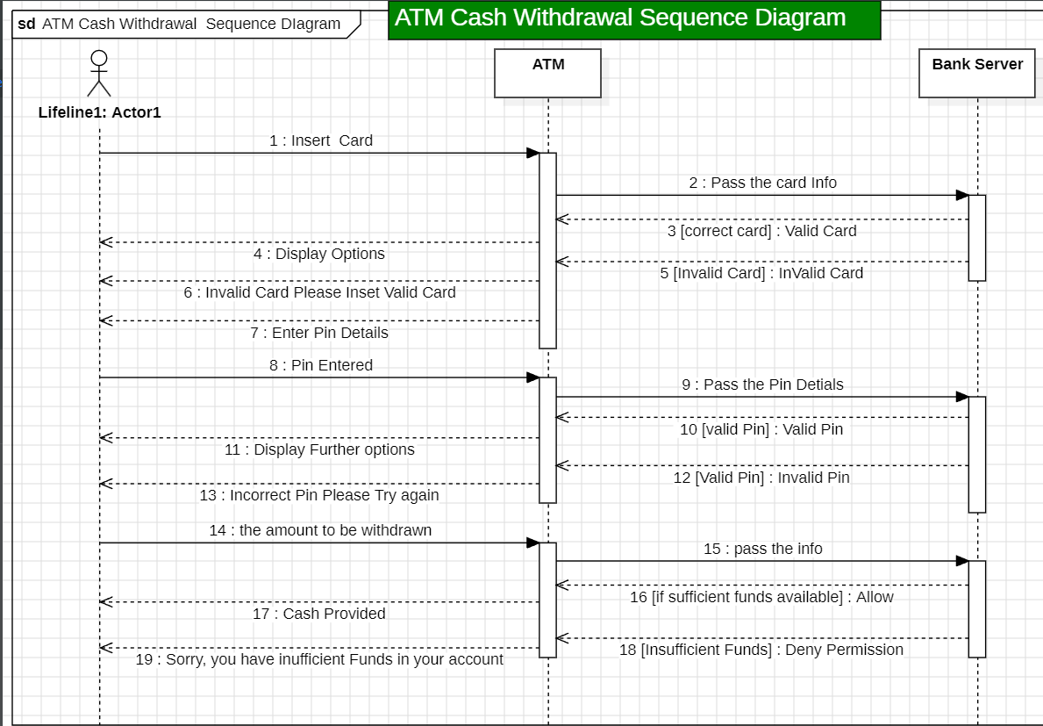

* 1. Library management system – Use case diagram

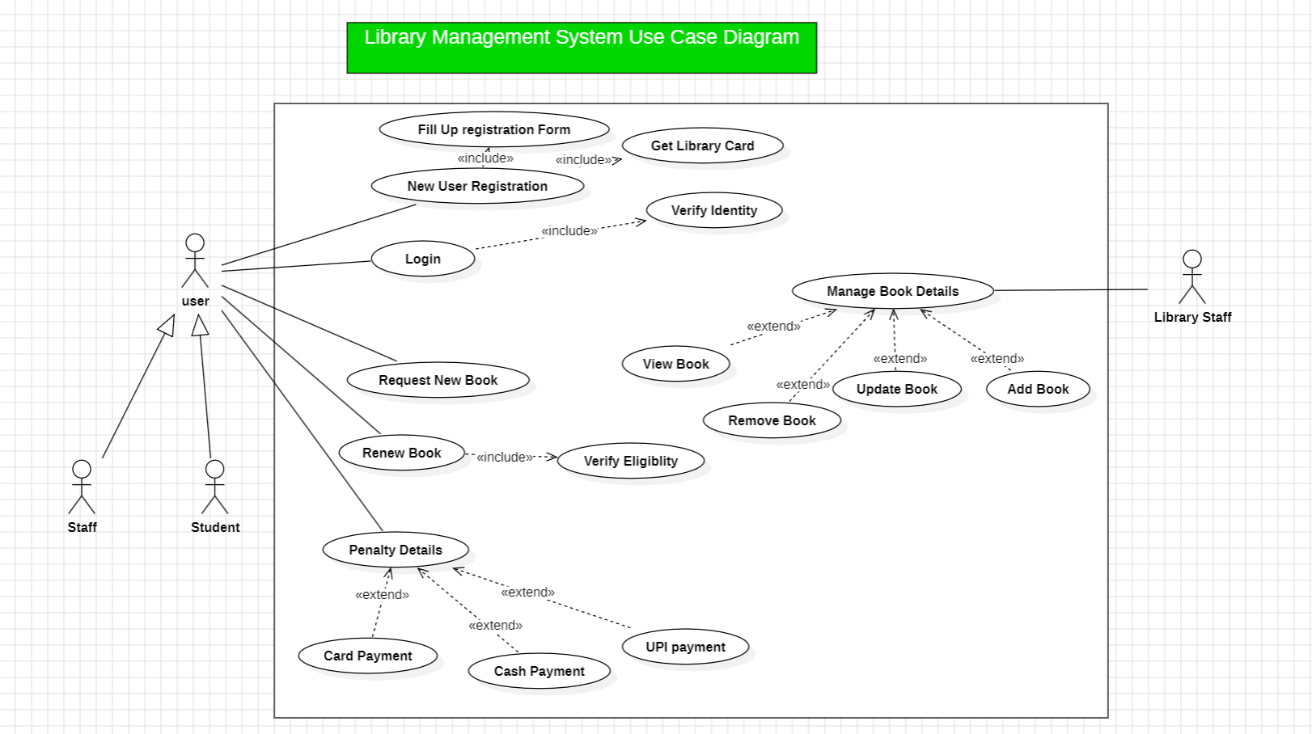

* 1. Login Page sequence Diagram

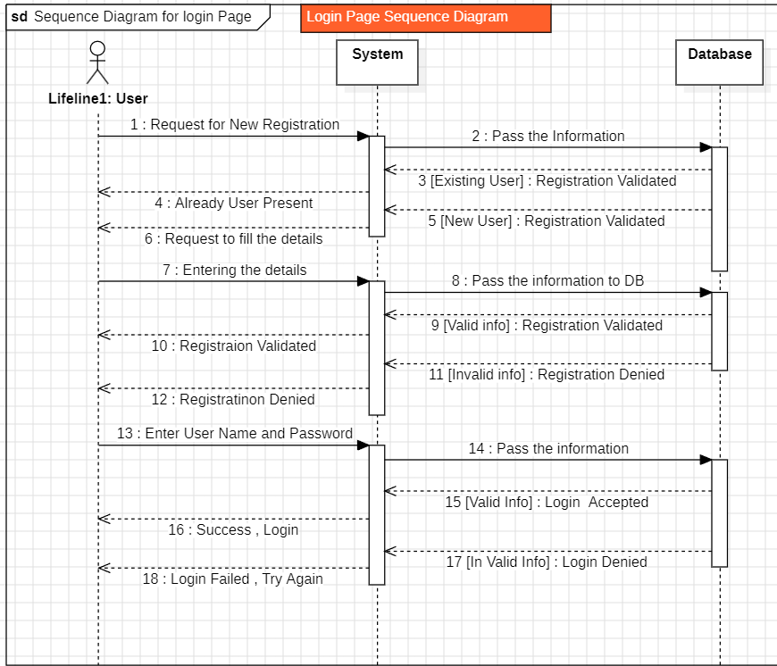

* 1. Online Shopping Use case Diagram

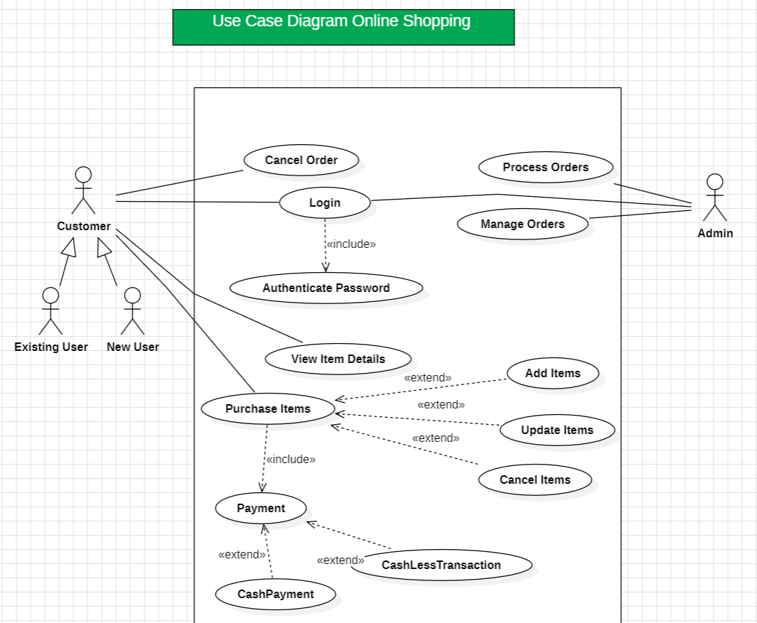

* 1. Online Ticket Booking Use case Diagram

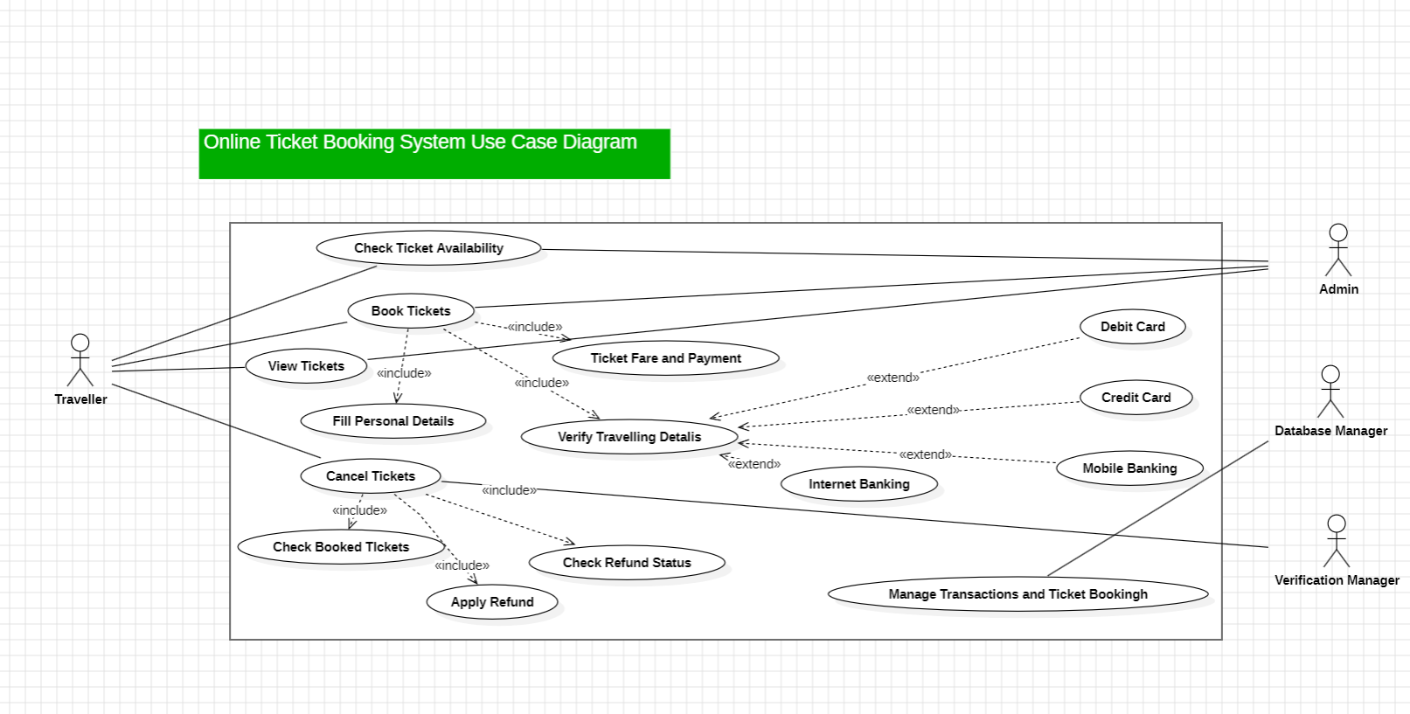

* 1. Sales Order System Class Diagram

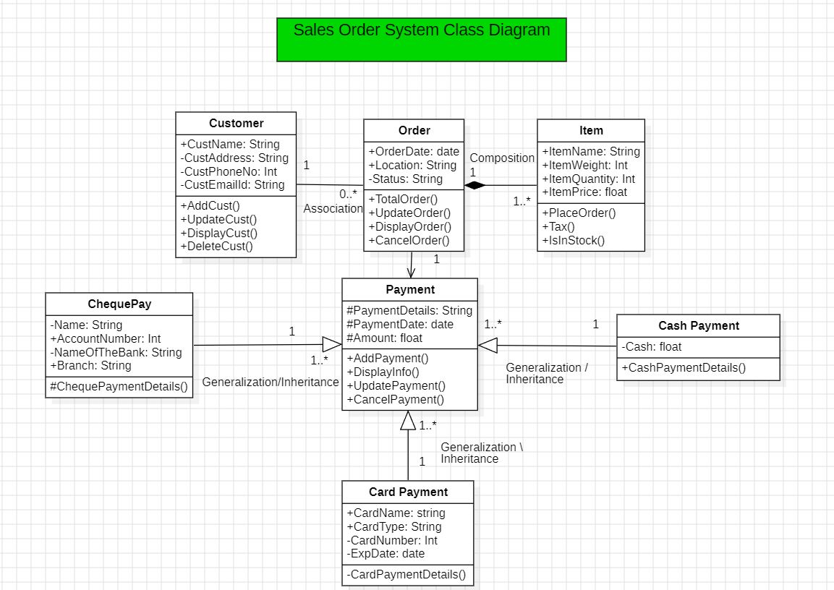

* 1. Online Shopping cart Activity Diagram

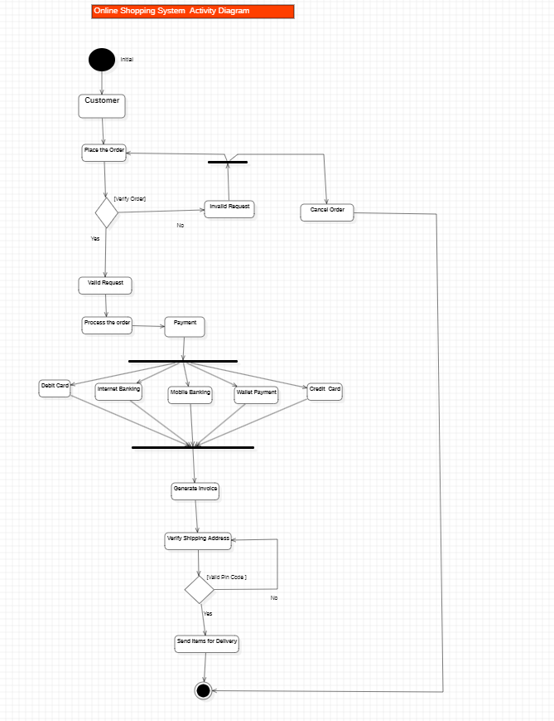

* 1. Object Diagram for Employee Management System

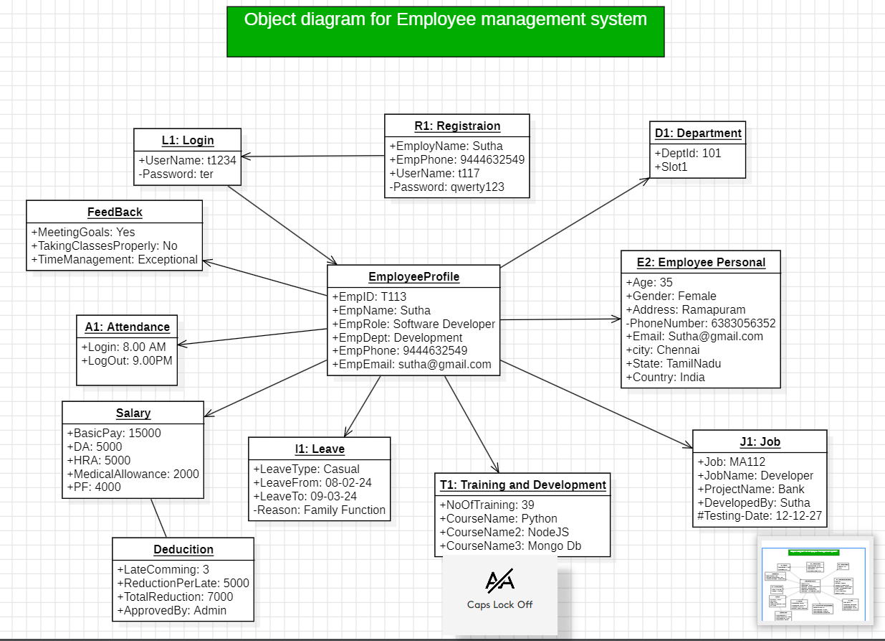

* 1. Object Diagram for Student Management System

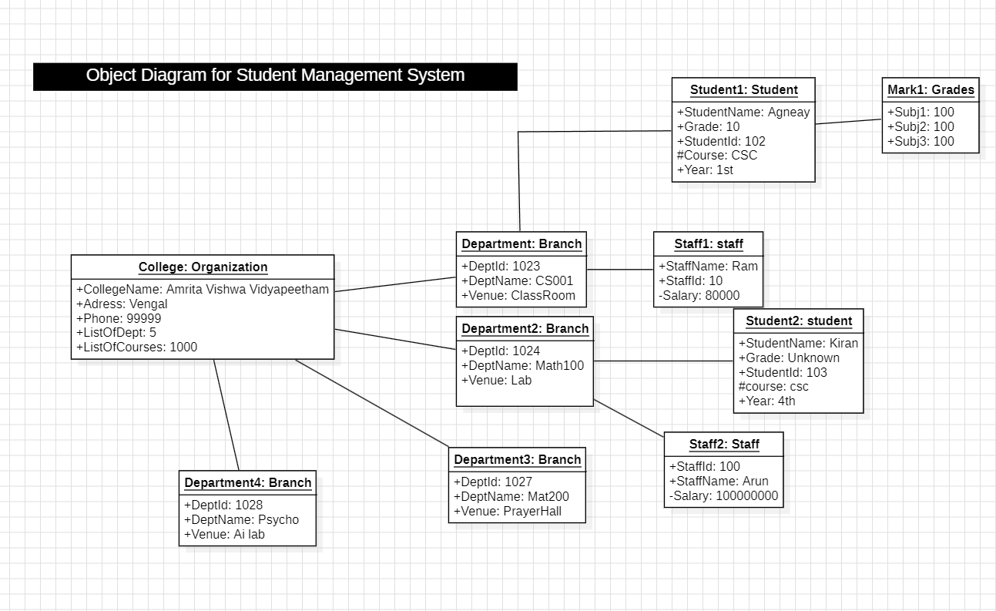

# Raptor Programs

* + 1. To find the square of a given number



* + 1. To find the product of two numbers



* + 1. To find the perimeter of a square



* + 1. To convert hours to seconds

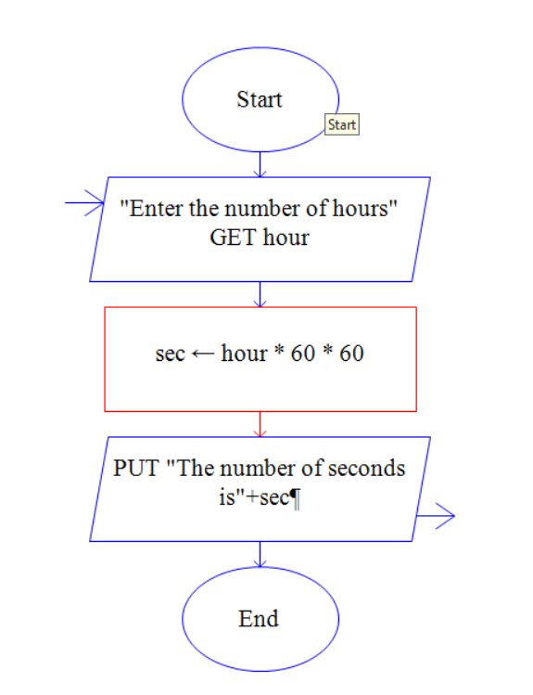

* + 1. To find the volume of a cube

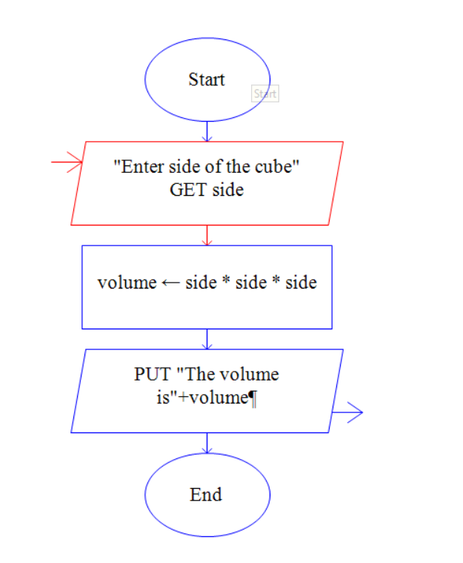

* + 1. To convert kilometre to meter

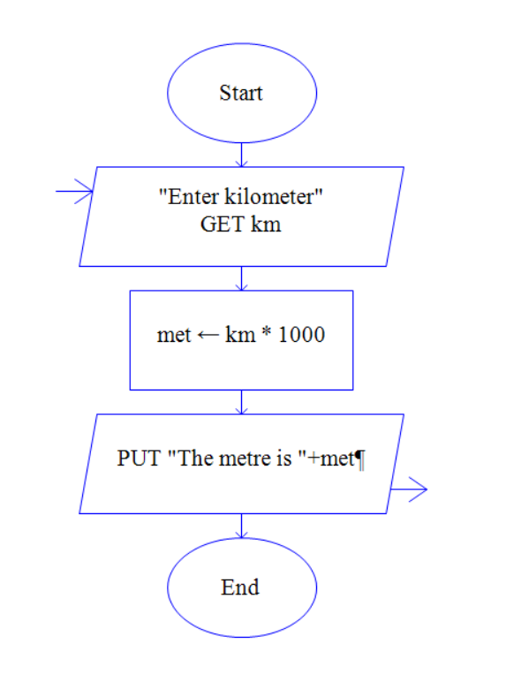

* + 1. To check if a person is eligible to vote

